(40 points)
French 4335
Luis F. Martinez
NAME: QUIZ 1 EIFFEL TOWER & CLUNY
I.D.

Exercise 1: Indicate the concept(s) associated by the following pieces of artwork or
icons or figures. Also indicate the name of the artist if applicable.

1.

2.

3.

4.

5.

6.
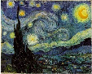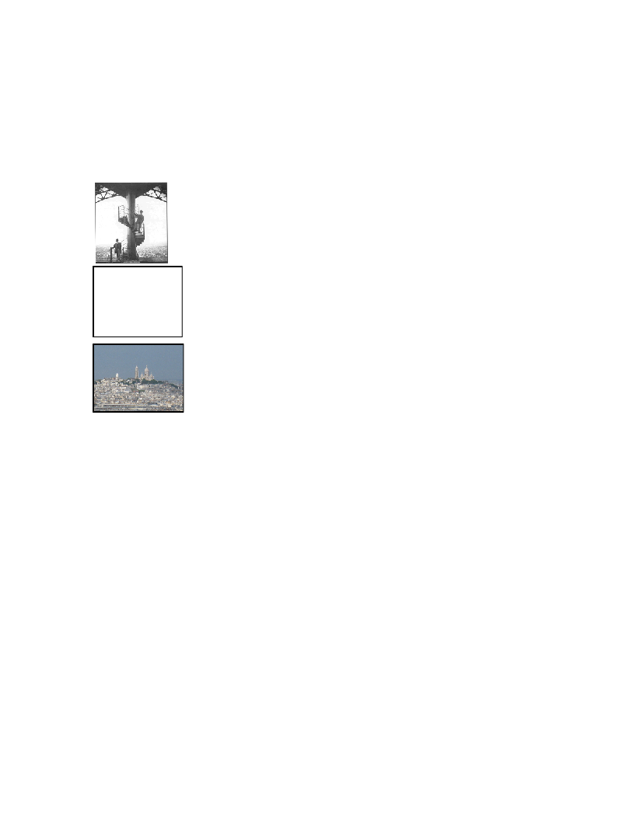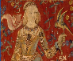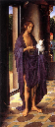

FRENCH 4335 QUIZ 1

- This is a photograph of Eiffel (bottom) at the lower staircase of the Eifel Tower. The tower was built for the World Fair of 1889. It represents liberty, technology and social progress. Also the downfall of the monarchy. This structure was so controversial that they thought of tearing it down in 1909 but it served as a very good antenna during World War II so it wasn’t demolished.
- This work of art is called Starry Night by Vincent Van Gogh. Van Gogh was an impressionist painter in the 20th century. His artwork was rejected by the Ecole de Beaux Arts so he used the World Fair to display his art. Starry night is one of the most well known paintings of Van Gogh.
- This is a panoramic photo taken from the top of the Eiffel Tower. The tallest structure seen is the Sacred Heart Basilica in Montmartre. After the French Revolution, the French had become anti-clerical, therefore they couldn’t allow the church to be the tallest structure. So they build the Eiffel Tower that represented reason and science. In other words, humans playing the role of God.
- This work of art is Jan Van Eych’s Knights of Christ (1432). This painting conveys a sense of the horseman’s religious devotion. In those times, it was an honor to die for their Lord’s cause. Also known as the chivalric code.
- This is one of the six tapestries woven in flanders of wool and silk titled The Woman and the Unicorn. This work of art is from the late 15th century and is often considered one of the greatest works of art of the middle ages in Europe. The tapestries represent the 5 senses and the 6th one has a different style.
- This is Hans Hemling’s painting Saint John the Baptist (1475). In the Middle Ages, common people had a lack of identity. Common people had no definition. Even artists would not sign their work and would not even paint themselves. If they did paint themselves, they would be hiding behind the saints like in the painting.
FRENCH 4335 QUIZ 1

Exercise 2: Terse and concise answers to the following conceptual questions.
Indicate an approximate date.
___15 billion years ago____“Birth” of the Universe— Big Bang

___5 billion years ago____“Birth” of Earth

___65 million years ago___Dinosaurs wiped off the planet

___6 million years ago____Australopithecines evolve

___150,000 years ago_____Homo Sapiens evolve

___100,000 years ago_____Homo Sapiens out of Africa

___40,000 years ago______Homo Sapiens to Europe

___15,000 years ago______Homo Sapiens to North America

___17,000 years ago______Cave paintings at Lascaux

___10,000 years ago______Non-nomadic peoples; end of the last Ice Age

___8,000 B.C.___________Clay tablets in Iraq

___3,100 B.C.___________Cuneiform writing in Ancient Mesopotamia

___3,000 B.C.___________Egyptian Hieroglyphics

