French 4335
(40 points)

NAME:Luis Martinez QUIZ 4 EIFFEL TOWER & CLUNY
I.D.

Exercise 1: Indicate the concept(s) associated by the following pieces of artwork or
icons or figures. Also indicate the name of the artist if applicable.

1
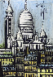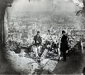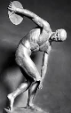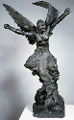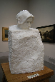
FRENCH 4335 QUIZ 4
- This is a painting of the Basilica Sacre Coeur/Montmarte by Bernard Buffet titled Montmarte (1996). The Basilica was built at the end of the 19th century. The Basilica sits high and can be seen through every part of Paris. One can see the influence of Eastern style of architecture like the domes for example.
- This is a photograph of a group of soldiers and cannons at Montmartre, where the French government housed an artillery park of cannons.
- This is a picture by Toulouse-Lautrec titled Bal au Moulin Touge (1890). Montmartre has always provided a home to the “Bohemians” since the 1830’s. This refers to gypsies because they thought they came from Bohemia.
- This picture is of the sculpture the Greek Athlete (500 B.C.) by Rodin. This picture shows us how they took so much importance for the sense of time and motion. The athlete seems to be immobile, frozen in time. He does not seem to be using force to throw the disc. He is just frozen in time.
- This is a picture of the sculpture The Dying Slave (1513-16) by Michelangelo. This sculpture is a lot more detailed than Rodin’s. It seems to be showing that the slave is already dead or about to die. The sculpture shows a considerable sense of emotion.
- This is a picture of the sculpture Aurora, Saint George, France and Thought by Rodin. The model is Camille Claudel, his model, student, assistante, muse, companion and lover. She was an artist as well and Rodin recognized her extraordinary talent.
2

