French 4335
(40 points)

NAME: QUIZ 3 VERSAILLES & THE PANTHEON
I.D.

Exercise 1: Indicate the concept(s) associated by the following pieces of artwork or
icons or figures. Also indicate the name of the artist if applicable.

1
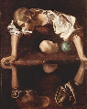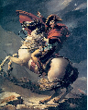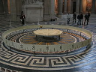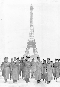

FRENCH 4335 QUIZ 3

- The first picture Narcissus by Carvaggio in the 16th century. In the painting one can see how Narcissus is admiring himself on the reflection so much that he fell into the pond and drowned. Its meaning is to not be so full of ourselves.
- The second picture is William Hamilton’s Marie Antoinette to the Guillotine (1794). It portrays the story of the beheading of the Queen when she was captured with King Louis XVI.
- The third picture is a work of art by Jacques Louis David. The picture is titled Napoleon crossing the Alps (1800). This picture says that not only was art used as a profession but it was used as a propaganda tool, in this case Napoleon to celebrate Napoleon’s successes.
- This is a picture of Marie and Pierre Curie. IT is to remind us how great philosophers were buried in the Pantheon. But why not Kings or queens? Because the Pantheon is a burial that serves as a symbol for intellectual history, like philosophers.
- This picture is an example of the experiment by Jean Leon Foucault. This hangs in the Pantheon. The experiment proves the motion of the earth.
- This picture is an example of what people remember of the parade of July 14th. Not a celebration of fireworks, but of the events that happened in history. France at one point suffered great losses against Germany in WWI and WWII and this picture is an example.
2
